Lab task NO: 5

213064

Khansa

3 /4/ 23

a) First of all create a recycler view of different cities of Pakistan along with their images on

Android Studio using linear Layout Manager.

**Step 1:** Create a new project Recyclerviewwithdetails. Here we will create a recyclerview in

LinearLayout. Below is the code of activity_main.xml or content_main.xml:

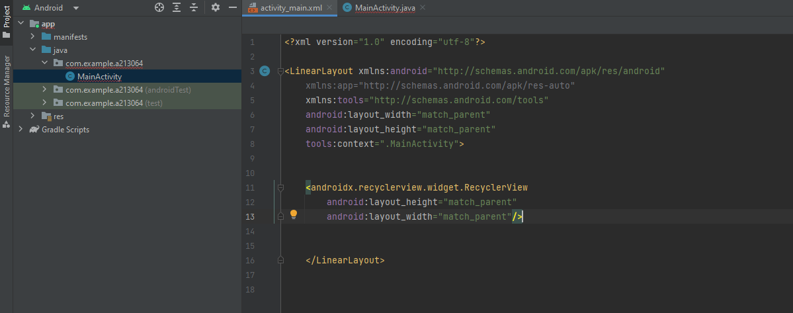

**Step 2:** Create linear layout and insert a RecyclerView from containers. This will be done in

activity_main.xml file.

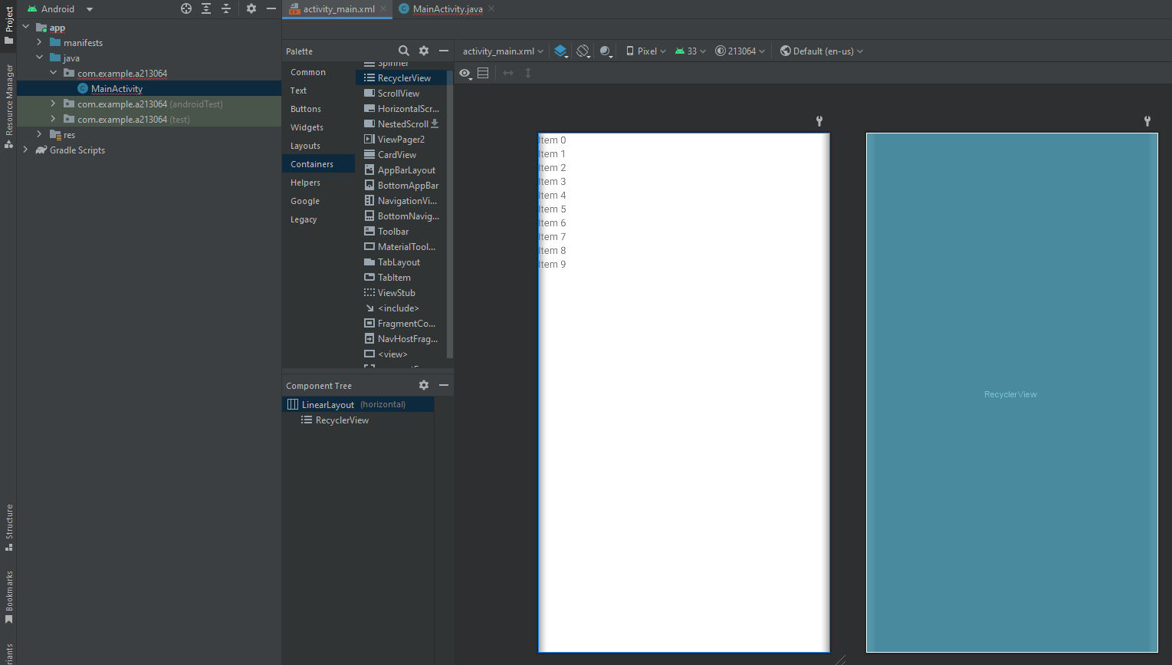

**Step 3:** Now we need to move towards backend code means java file.

a) First on all write RecyclerView recyclerView; in class Mainactivity before onCreate

section. Now in onCreate section, we need to findViewById. So we need to write following

code.

1. recyclerView= findViewById (R.id.recyclerView);

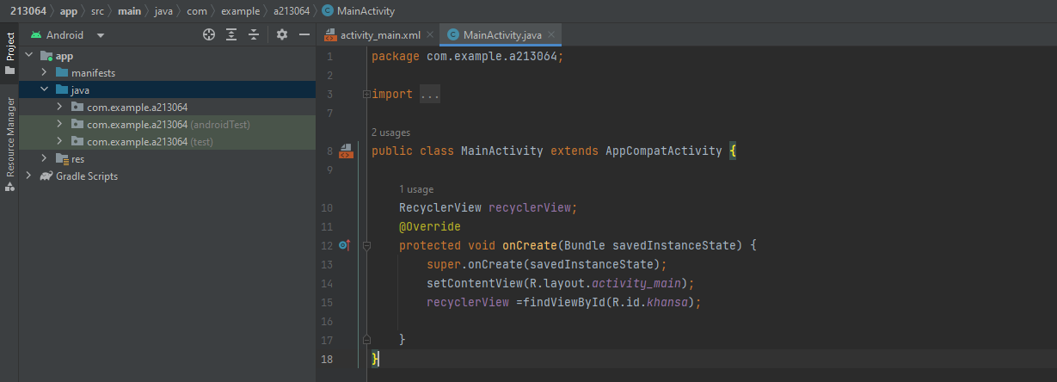

**Step 4:**

a) Now we need to make a layout for RecyclerView and we need image and text for that so

for that purpose we will go to res folder and in layout section. We will click right on layout

and from new will move towards layout resource file and click on it and then.

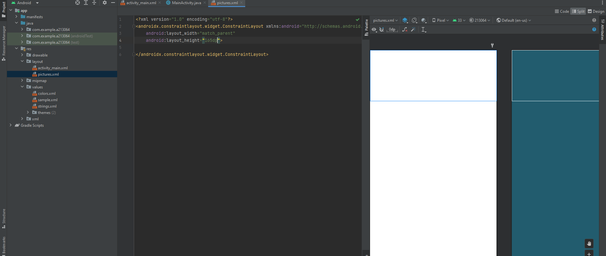

Sample_recyclerview.xml File

c) Now we set its layout_height equal to 165dp to show 4 items on one screen along images

and captions.

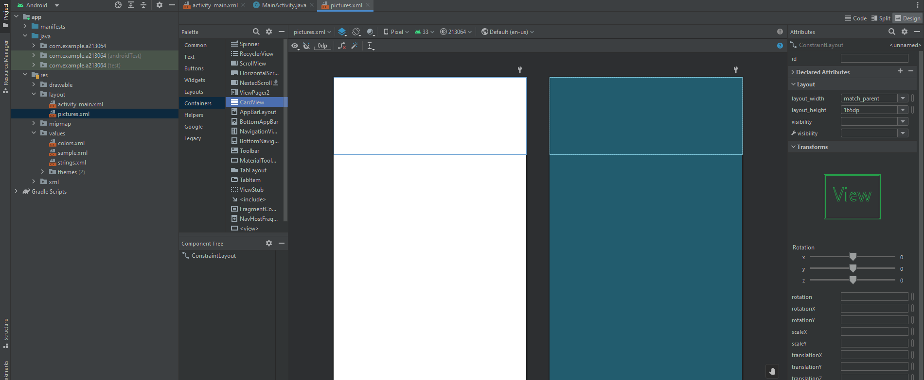

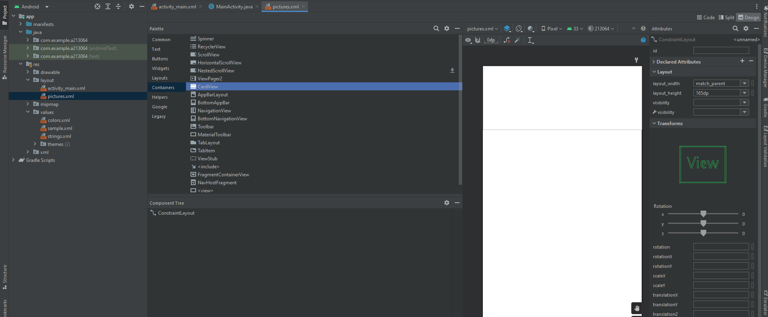

Now we have to use CardView in sample_recyclerview.xml file to perform spacing, margins and

set size after every list.

Now we want to add image and for that purpose we have to make sure that image is present in

drawable section. So we will go towards drawable section and will click right and click on **open**

**in Explorer** and will add different downloaded images in drawable folder.

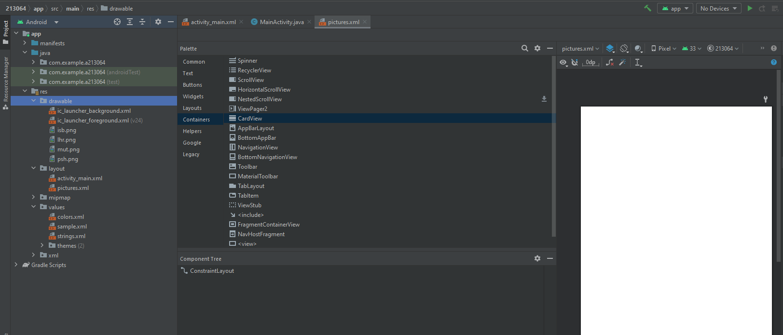

First of all, we have to add LinearLayout in CardView section. Further we have to add imageView

and have to select relevant image from drawable section. Now we have to set its gravity, margins

and size according to the user interface requirements. We use **scaletype** for setting the image according to the screen.